
Studies from big research and industry associations like Gartner and CompTIA have shown that the average small-to-medium-sized businesses lose thousands of dollars a year to network downtime.

Red I.T Solutions delivers proactive managed services that keep your network up and running at optimal efficiency, with superior network performance, security, and reliability—all at an affordable price.

WE OFFER:
24 x 7 Monitoring and Alerting
- Red I.T. Solutions will proactively monitor your network and remotely address potential points of failure before they become critical
- When a site visit is required, immediate, automatic alerts guarantee a rapid response

Asset Management
- Initial network scan to discover and assess potential points of failure
- Ongoing scanning for up-to-date hardware, software and patch information that can also be used for theft, flood and fire insurance or taxation purposes
- Warranty tracking makes sure you don’t pay for maintenance twice

Security Assurance
- Extensive reporting gives you a bird’s-eye view of your entire network’s security
- Continuous monitoring and alerting for viruses, worms, malware, and attempted network access by unauthorized users
- Network scans will also detect high-bandwidth interactive games or illegal peer-to-peer file sharing applications that monopolize business resources and often introduce viruses and spyware
- Patch inventory ensures your operating systems are up-to-date and not exposed to vulnerabilities

Preventative Maintenance
- Red I.T. Solutions minimizes disruptions to your work environment by resolving issues proactively
- Deep, remote visibility into the health and performance of your IT assets allows us to diagnose problems faster than ever

Reporting
- You’ll get comprehensive, graphical reports every month
- Accurate, up-to-date data simplifies capacity management and upgrade planning

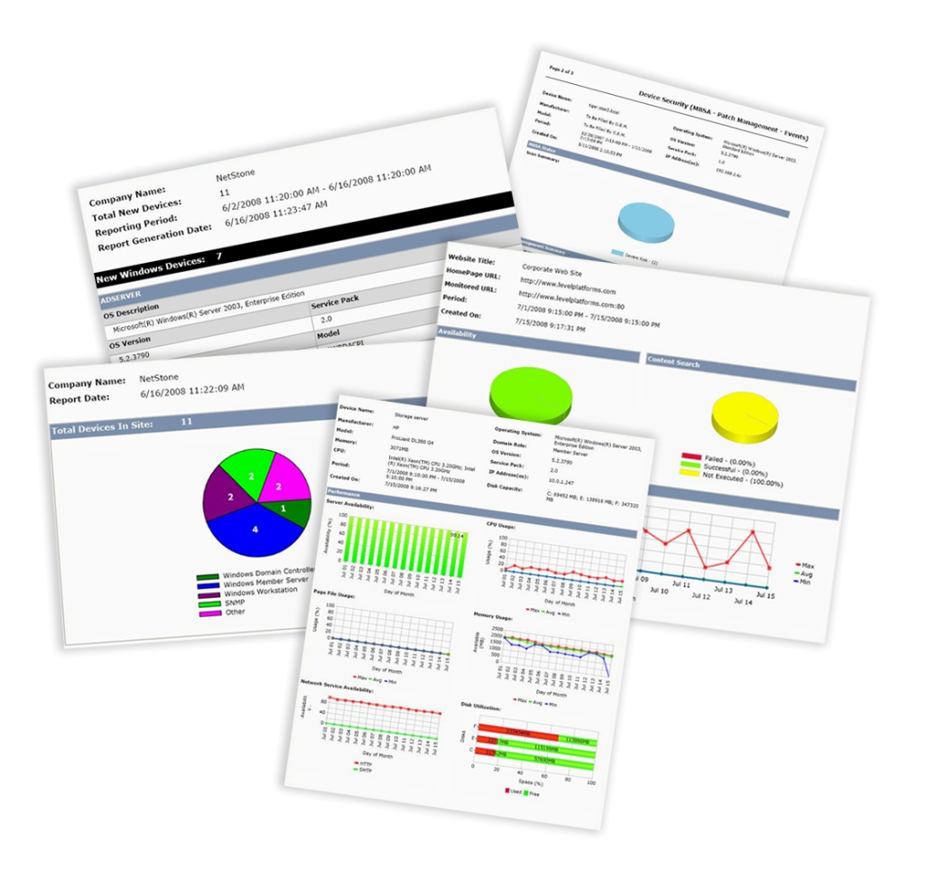
Quarterly Business Reviews
- We’ll meet every quarter to discuss the overall health and performance of your IT assets and ways to get the most out of your investments
- Extensive data about your IT will support more accurate budget forecasting

c

Feature | Benefit | Value
24 x 7 Monitoring and Alerting  - Network and device availability  - Immediate, automatic alerts and pre-failure indicators | We will identify IT issues much faster—often before you experience problems—and address them proactively. | You will see a reduced cost of downtime, and minimize the resulting lost opportunities, lost productivity, and service costs.
Asset Management  - Initial network assessment  - Asset inventory management  - Detailed network audits  - Warranty tracking | You will get accurate, up-to-date asset and warranty tracking for fire, flood and theft insurance or taxation purposes. | You will save money with better asset life-cycle management, and you will never pay twice for maintenance.
Security Assurance  - Baseline security scanning  - Continuous monitoring for viruses, worms and malware  - Automated verification of backup successes and failures | Protect your assets and data with round-the-clock protection from virus, malware and other attacks; achieve regulatory compliance with legislation relevant to your industry. | You will reduce downtime and its associated costs, while increasing customer confidence.
Preventative Maintenance  - Automated scripting  - Automated security patching | Lengthen the lifespan of your assets and minimize technology problems that reduce productivity. | Your team can get more done, and you’ll reduce expenditures on emergency repairs.
Reports  - Detailed, graphical monthly reports | You will always know exactly what is going on in your network, and be able to identify and analyze pending issues. | You will be able to optimize every dollar you spend on IT based on accurate, detailed data.
Quarterly Business Reviews  - Detailed needs assessment  - Set objectives and plan for improvements | An opportunity to prioritize projects, plan budgets, and discuss solution optimizations | You will be able to conduct more accurate budget forecasting based on the facts.

Contact Us for More Information
Red I.T. Solutions Inc
Telephone: (941) 981-4260
Address: PO Box 265, Ellenton, FL 34222
Email: requests@red-itsolutions.com

